Press release: Mearrasápmelaš / Sea sámi- New album from Johan Sara jr.
The time has come to honor the Sea Sami coastal population in Northern Norway.

The Norwegian authorities westernization policy towards the Sea Sámi population where particularly vicious in erasing their culture and language.

From 1850 and well into the 20th century, the Sámis were to be assimilated into Norwegian society. This Norwegianization policy implemented by the Norwegian authorities struck the Sea Sámi population particularly hard.
Their culture was largely erased, and subsequently as a result of the assimilation, they have associated their sámi identity with disgrace and shame.
Sea sámi Joik tradition (joik is a unique form of cultural expression for the Sami people in form of a solo chant/singing) has been almost completely wiped out, with only a few surviving fragments that we know of.

This release, as the first in a coming trilogy, is set in a Sea Sámi context, and concerns to reconstruct and bring back to life some of the the spirit and sound of the original Sea Sámi joik.

This first album will be availeble on vinyl and streaming, and contains two long works. (One on each side). The trilogy is a larger coherent art project on vinyl, of which the cover design is also a part.

For ages the sea sámi population lived on the coast combining reindeer husbandry, agriculture and fishing.
Johan Sara jr. - joiker, composer and musician is himself coming from Sea Sámi heritage, growing up in Alta and on Stjernøya. His family was engaged in reindeer husbandry, living partly nomad life with summer pasture on Stjernøya, besides a permanent residency in Alta where the reindeers had their winter pasture.

With this album, Sara jr. wants to highlight and set focus on the Sámi population living along the coast of northern Norway.
Through the music, Johan and his fellow musicians depicts and reflects on the coast from a Sámi perspective.
The length of the works stands in contrast to the busy times we live in. They linger and change slowly, just as the light and weather change in the fjords and along the coast.

This trilogy has it’s fundings on the three instruments we know about from sámi music culture; voice, flute and drums.

Alongs side Johan Sara jr. on this trilogy, there are two brilliant musicians: Erik Håkon Halvorsen on keys, and Stein Inge Brækhus on drums and percussion. As a trio they are forming a close listening interaction, based on improvisation; low and high, calm and storm, love and strength. deep and heartfelt.
The joik is examined with different use of voices and variations in a sounding landscape based on Sámi philosophy and mythology.

Guest musician on various flutes from Turkey is Serdar Kastelli
Johan Sara jr.: producer, art work and cover design.
The publication is supported by the Sámi Parliament.
Contact /booking: Johan Sara jr., tlf. (+47) 976 18383. E-post: johansara@gmail.com www.stierdna.com
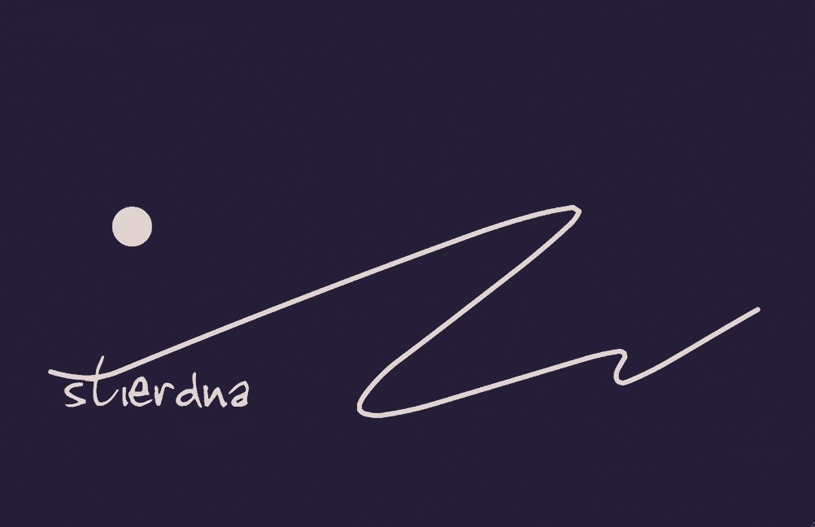
STI19 CD All rights reserved © & P 2023 STIERDNA, pb 95,N-9525 Máze www.stierdna.com johansara@gmail.com Stierdna facebook RLabel www.musikkoperatorene.no

